Faculty of Information Technology
Middle East University
MEU Transportation Platform

User Stories, Use Cases & Functional Specifications

Submitted By:
Anas Hassan Abu Dahak — 202310943
Mohammad Ali Atari — 202311859
Mohammad Nader Al-Toubeh — 202310949

Supervisor: Dr. Ahmad Hasan
Academic Year 2025 / 2026 | Second Semester

Part 1: User Stories
User stories describe the system from the perspective of the people who actually use it. Each story captures a real need in plain language and includes clear acceptance criteria so the development team knows exactly when that need has been met.

1.1 Student Stories
US-01 — User Story
As a | student
I want to | log in to the app using my university credentials
So that | I can access my personalized transportation information securely
Acceptance Criteria | - Login form accepts valid university username and password  - Incorrect credentials display a clear, friendly error message  - After 5 failed attempts, the account is temporarily locked  - Session persists until the student explicitly logs out or the session times out

US-02 — User Story
As a | student who forgot my password
I want to | recover access through my university email
So that | I am never permanently locked out because of a forgotten password
Acceptance Criteria | - A 'Forgot Password' link is visible on the login screen  - A reset link is sent to the registered university email within 2 minutes  - The reset link expires after 30 minutes for security  - After resetting, the student is redirected to the login page

US-03 — User Story
As a | student
I want to | choose whether I am travelling to or from the university
So that | I can quickly find routes that match the direction I am heading
Acceptance Criteria | - The home screen prominently shows 'To MEU' and 'From MEU' options  - Selecting either option takes me to the relevant list of available routes  - Both options are available in Arabic and English

US-04 — User Story
As a | student
I want to | see all available routes with estimated arrival times
So that | I can plan my journey without guessing or waiting in uncertainty
Acceptance Criteria | - Each route card shows: route name, estimated arrival time, number of buses, and station count  - The list refreshes automatically every 30 seconds  - If no buses are available, a friendly message explains why

US-05 — User Story
As a | student
I want to | tap on a route and see full details — bus number, stations, and driver contact
So that | I know exactly which bus to board and who to call if something goes wrong
Acceptance Criteria | - Detailed view shows bus number, current passenger count, station schedule, and driver phone  - I can call the driver directly from within the app  - A map view shows the route path and current bus position

US-06 — User Story
As a | student
I want to | rate the transportation service after my trip
So that | My feedback helps the university continuously improve the service
Acceptance Criteria | - A rating prompt appears after completing a trip  - The rating uses a 1–5 star scale with an optional comment box  - Ratings are submitted anonymously  - I can skip the rating prompt if I choose

US-07 — User Story
As a | student
I want to | view and manage my profile information
So that | I can verify my personal details are correct at any time
Acceptance Criteria | - The profile page displays my name, student number, and major  - I can update my contact preferences  - A 'Sign Out' button is clearly visible and always accessible

1.2 Driver Stories
US-08 — User Story
As a | bus driver
I want to | log in to the driver app with my university credentials
So that | I can access my assignments and trip information securely
Acceptance Criteria | - The driver app has a dedicated login screen  - Successful login loads today's assigned trips immediately  - An error is shown if credentials are invalid

US-09 — User Story
As a | bus driver
I want to | start and end my trip with a simple tap
So that | The system always knows when my bus is active so students get accurate real-time data
Acceptance Criteria | - 'Start Trip' button activates GPS tracking and broadcasts my location  - 'End Trip' button stops tracking and closes the trip record  - Students see my bus as 'Active' during the trip and 'Completed' afterward

US-10 — User Story
As a | bus driver
I want to | see how many students are currently on board automatically
So that | I do not need to count passengers manually while driving
Acceptance Criteria | - Passenger count updates automatically when the onboard scanner detects boarding or exiting  - The count is visible on my screen at all times during an active trip  - Any sensor error is flagged with an alert and I can enter the count manually

1.3 Administrator Stories
US-11 — User Story
As a | system administrator
I want to | manage routes, schedules, and bus assignments from a web dashboard
So that | Transportation operations run smoothly and data stays accurate
Acceptance Criteria | - I can create, edit, and delete routes without developer assistance  - I can assign a driver and bus to a specific route and time slot  - Changes take effect immediately and are visible to students in the app

US-12 — User Story
As a | system administrator
I want to | monitor all active buses on a live map
So that | I can quickly detect and resolve any operational issues
Acceptance Criteria | - The dashboard shows all active buses with their current location  - I can click any bus to see its route, driver, passenger count, and status  - Buses that are overdue or offline are highlighted in red

US-13 — User Story
As a | system administrator
I want to | send notifications to students or drivers
So that | Everyone is informed promptly when schedules change or problems arise
Acceptance Criteria | - I can compose and send a push notification to all users, a specific route, or a single user  - Notifications are delivered within 30 seconds  - Sent notifications are stored in a history log

Part 2: Use Cases
Use cases describe the interactions between actors and the system in a structured, step-by-step format. They make it clear what the system must do — not how it does it — and cover both the normal path and the things that can go wrong.

2.1 Use Case Diagram
The diagram below shows all system actors (Student, Driver, Administrator) and their relationships with the use cases inside the MEU Transportation System boundary. Dashed arrows indicate «include» (mandatory sub-flows) and «extend» (optional extensions) relationships.

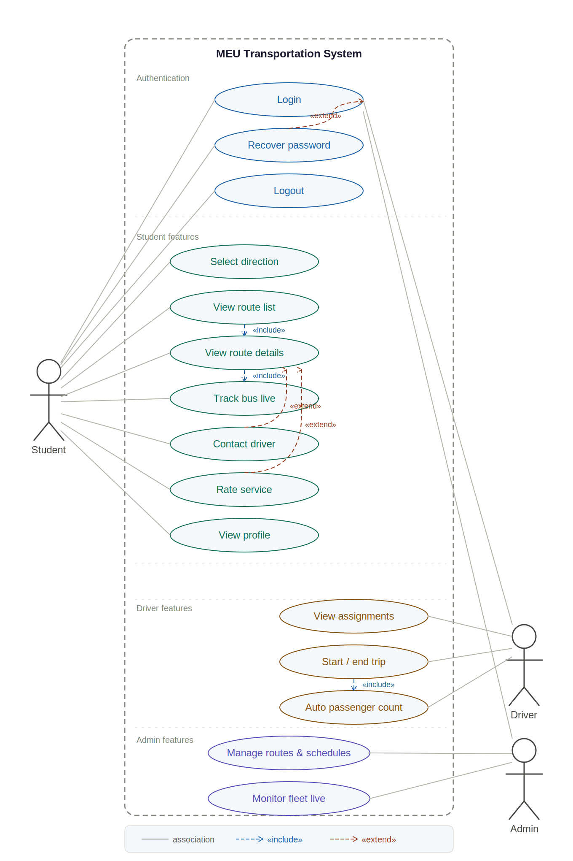

2.2 UC-01: Student Login
UC-01 — Student Login
Actors | - Student (primary), Authentication Service (secondary)
Preconditions | The student has the mobile app installed and has not yet logged in.
Main Flow | - Student opens the app and arrives at the Login screen  - Student enters university username and password  - App sends credentials to the Authentication Service  - Authentication Service validates credentials against the university database  - System creates a secure session and navigates the student to the Home screen
Alternative / Exception Flow | - Invalid credentials — system shows an error: 'Incorrect username or password. Please try again.'  - Five consecutive failures — account is locked for 15 minutes and an email is sent to the student  - No internet — system shows an offline banner and disables the login button until connectivity is restored
Postconditions | Student is authenticated and can access all app features.

2.3 UC-02: View Available Routes
UC-02 — View Available Routes
Actors | - Student (primary), Backend API (secondary)
Preconditions | Student is logged in and has an active internet connection.
Main Flow | - Student taps 'To MEU' or 'From MEU' on the home screen  - App sends a request to the backend API for available routes  - Backend returns route list with estimated times and bus counts  - App displays route cards sorted by estimated arrival time  - Student scrolls through the list and selects a route of interest
Alternative / Exception Flow | - No routes available — system shows: 'No buses are currently scheduled for this direction.'  - API timeout — system shows a retry button and a friendly error message  - Stale data — a timestamp shows when data was last refreshed; a manual refresh button is available
Postconditions | Student sees an up-to-date list of routes and can proceed to view route details.

2.4 UC-03: View Route Details & Contact Driver
UC-03 — View Route Details & Contact Driver
Actors | - Student (primary), Driver (indirect), Phone System (secondary)
Preconditions | Student has selected a route from the available routes list.
Main Flow | - App loads the Route Detail screen for the selected route  - Screen displays: bus number, live passenger count, station names and times, and driver phone number  - A map widget shows the bus position updating in real time  - Student taps the 'Call Driver' button  - The device's native phone dialer opens with the driver's number pre-filled  - Student completes or cancels the call outside the app
Alternative / Exception Flow | - Driver contact unavailable — button is greyed out with tooltip: 'Driver contact not available right now'  - Bus location unavailable — map shows last known position with a disclaimer timestamp  - Student's device cannot make calls — system shows: 'Your device cannot make phone calls.'
Postconditions | Student has access to complete, real-time route information and can contact the driver if needed.

2.5 UC-04: Driver Starts a Trip
UC-04 — Driver Starts a Trip
Actors | - Driver (primary), GPS Service (secondary), Student App (secondary)
Preconditions | Driver is logged in and has an assigned trip for today.
Main Flow | - Driver opens the Driver App and views today's trip list  - Driver taps the assigned trip to open trip details  - Driver verifies route, start time, and bus assignment  - Driver taps 'Start Trip'  - App activates GPS tracking and begins broadcasting location  - Student app shows the bus as 'Active' with a live position marker  - Passenger count sensor is activated automatically
Alternative / Exception Flow | - GPS unavailable — system alerts driver and retries every 30 seconds; students see 'Location temporarily unavailable'  - Wrong bus — if the scanned bus ID does not match the assigned trip, an alert asks the driver to confirm or correct  - Trip started early — a confirmation dialog asks: 'You are starting this trip 15 minutes early. Continue?'
Postconditions | The trip is active, GPS tracking is live, and students can see real-time bus information.

2.6 UC-05: Admin Manages Routes
UC-05 — Admin Manages Routes
Actors | - Administrator (primary), Backend System (secondary)
Preconditions | Administrator is logged in to the web admin panel with route management permissions.
Main Flow | - Admin navigates to the 'Routes' section of the dashboard  - Admin views the full list of existing routes  - Admin clicks 'Add New Route' or selects an existing route to edit  - Admin fills in or updates: route name, stations, schedule, and assigned bus/driver  - Admin clicks 'Save'  - System validates the input and saves the route to the database  - Changes are immediately reflected in the student app
Alternative / Exception Flow | - Missing required fields — system highlights empty fields and shows: 'Please complete all required fields before saving.'  - Duplicate route name — system warns: 'A route with this name already exists. Would you like to rename it?'  - Assigned driver has a schedule conflict — system alerts admin and suggests available alternatives
Postconditions | Route is saved and instantly visible to students. Old route data is archived for reporting.

Part 3: Functional Specifications
Functional specifications define exactly what the system must do. Each requirement is written precisely so that developers know what to build and testers know what to verify. Requirements are prioritised as High, Medium, or Low based on their importance to core operations.

3.1 Authentication & Account Management
FR ID | Feature | Description | Priority
FR-01 | Secure Login | The system must authenticate students, drivers, and admins using their university credentials via an encrypted connection (HTTPS/TLS). | High
FR-02 | Password Recovery | Users must be able to request a password reset link sent to their registered university email. The link must expire after 30 minutes. | High
FR-03 | Account Lockout | After 5 consecutive failed login attempts, the account must be locked for 15 minutes. The user must receive an email notification. | High
FR-04 | Session Management | Authenticated sessions must remain active for up to 24 hours of inactivity. Sessions must be invalidated on logout. | High
FR-05 | Profile Display | The student app must display the user's full name, student number, and major on their profile page. | Medium

3.2 Route & Bus Selection
FR ID | Feature | Description | Priority
FR-06 | Direction Selection | The home screen must present 'To MEU' and 'From MEU' as the two primary navigation options. | High
FR-07 | Route List | The system must display all available routes for the selected direction. Each card must show route name, estimated arrival time, number of buses, and number of stations. | High
FR-08 | Auto-Refresh | Route data must refresh automatically every 30 seconds without requiring user action. | High
FR-09 | Route Details | Tapping a route must display: bus number, live passenger count, per-station times, and driver phone number. | High
FR-10 | Driver Call | The system must allow students to initiate a call to the driver directly from the route detail screen using the device dialer. | Medium

3.3 Real-Time Tracking
FR ID | Feature | Description | Priority
FR-11 | Live Bus Location | The system must display the real-time GPS position of active buses on a map, updated at least every 10 seconds. | High
FR-12 | Passenger Count | The system must automatically update the passenger count on a bus using the onboard scanner or sensor. Manual override must be available for sensor failures. | High
FR-13 | Trip Status | Each bus must have a visible status: Active, Delayed, Completed, or Unavailable. Status changes must be reflected within 5 seconds. | High
FR-14 | ETA Calculation | The system must calculate and display estimated arrival times for each station based on current bus position and historical travel data. | Medium

3.4 Notifications
FR ID | Feature | Description | Priority
FR-15 | Push Notifications | The system must support push notifications delivered to all users, a specific route group, or an individual user within 30 seconds of sending. | High
FR-16 | Delay Alerts | The system must automatically trigger a delay notification to affected students when a bus is more than 5 minutes behind schedule. | High
FR-17 | Notification History | All sent notifications must be stored and viewable by the admin in a log for at least 90 days. | Medium
FR-18 | In-App Alerts | Critical alerts (e.g. route cancellation) must also appear as in-app banners even if the user has disabled push notifications. | Medium

3.5 Rating & Feedback
FR ID | Feature | Description | Priority
FR-19 | Trip Rating | After a trip is marked as completed, the student app must prompt the user to rate the service on a 1–5 star scale within 2 hours. | Medium
FR-20 | Optional Comments | The rating prompt must include an optional free-text comment field of up to 500 characters. | Low
FR-21 | Rating Anonymity | Ratings and comments must be stored without linking them to the student's identity in any user-facing display. | Medium
FR-22 | Rating Dashboard | The admin panel must display average ratings per route, per driver, and system-wide with trend charts. | Low

3.6 Admin Panel
FR ID | Feature | Description | Priority
FR-23 | Route Management | Admins must be able to create, edit, and delete routes. Changes must propagate to all user devices within 60 seconds. | High
FR-24 | Driver & Bus Assignment | Admins must be able to assign a driver and bus to a route/time slot. The system must flag scheduling conflicts. | High
FR-25 | Live Fleet Map | The admin dashboard must show all active buses on a live map with clickable pins showing driver, route, and passenger count. | High
FR-26 | Reporting | The system must generate exportable reports (CSV/PDF) on route usage, passenger counts, and ratings for any selected date range. | Medium
FR-27 | Role-Based Access | Admin accounts must support at least two roles: Super Admin (full access) and Operator (read-only monitoring and notifications). | High

3.7 Multilingual Support
FR ID | Feature | Description | Priority
FR-28 | Arabic & English UI | All user-facing screens must be fully translated into both Arabic and English. Text direction must switch correctly (RTL for Arabic, LTR for English). | High
FR-29 | Language Toggle | Users must be able to switch between Arabic and English from the settings or profile page at any time without losing their session. | Medium

3.8 Non-Functional Requirements
The following non-functional requirements define the quality constraints the system must operate within:

Category | Requirement
Performance | The app must load the route list within 2 seconds on a standard 4G connection.
Availability | The system must maintain 99.5% uptime, with scheduled maintenance only during off-peak hours (2 AM – 4 AM).
Security | All data in transit must be encrypted using TLS 1.2 or higher. Passwords must be stored as salted hashes.
Scalability | The architecture must support at least 2,000 concurrent users without performance degradation.
Usability | A first-time user must be able to find and view route information within 3 taps of opening the app.
Compatibility | The mobile app must support Android 9+ and iOS 14+. The admin panel must work in Chrome, Edge, and Firefox.
Maintainability | The codebase must follow modular architecture so individual components can be updated without affecting others.

